Project Audit Report
EcoSand Cleaner: Automated Beach Debris Cleaner

Prepared by:

Dado, Kenneth S.
Fajutagana, Kimberly A.
Balimbingan, Shaina F.
Dacatimban, Kristine Jewel M.
Fernandez, Robyn Kristoffer P.

May 2026

ECOSAND CLEANER
Automated Beach Debris Cleaner — Project Audit Report
Audit Date: | May 25ss, 2026
Report Generated: | May 25, 2026
Total Project Cost: | ₱17,187.00
Currency: | Philippine Peso (₱)
Total Line Items: | 55 items
Audit Reference: | ECOSAND-AUD-2026-001

I. EXECUTIVE SUMMARY
The EcoSand Cleaner project represents an automated beach debris cleaning system with a total audited expenditure of ₱17,187.00. The project spans 6 major procurement categories, with the bulk of investment concentrated in two core areas: Tools & Electronics (42.67%) and Materials & Fabrication (29.93%) — together accounting for 72.60% of total project costs.
Total Items Audited: 55 line items across 6 categories
Grand Total Expenditure: ₱17,187.00
Audit Reference: ECOSAND-AUD-2026-001

II. DETAILED EXPENDITURE REGISTER
# | Item Description | Category | Qty | Amount (₱)
MATERIALS & FABRICATION
1 | Sheet 12x12 & 17x36 Pipe | Materials & Fabrication | 1 | ₱1,450.00
2 | RL Bar | Materials & Fabrication | 1 | ₱500.00
3 | 11x16 Sheet 2.0 | Materials & Fabrication | 1 | ₱500.00
4 | SG. J 3/6 x 3/4 16' | Materials & Fabrication | 1 | ₱96.00
5 | 5mm Bolts (Helts) | Materials & Fabrication | 1 | ₱88.00
6 | Repair Project | Materials & Fabrication | 1 | ₱410.00
7 | Project (Fabrication) | Materials & Fabrication | 1 | ₱500.00
8 | Labor | Materials & Fabrication | 1 | ₱1,600.00
TOOLS & ELECTRONICS
9 | Screw Drivers (Set) | Tools & Electronics | 1 | ₱93.00
10 | High Capacity 24V 300000mAh Battery | Tools & Electronics | 1 | ₱1,733.00
11 | Solar Panel | Tools & Electronics | 1 | ₱940.00
12 | Jumper Wires Dupont Line Male | Tools & Electronics | 1 | ₱71.75
13 | Motor DC 24V 250W Motor | Tools & Electronics | 1 | ₱717.00
14 | High Sensitivity SW-420 Vibrator Sensor | Tools & Electronics | 1 | ₱123.00
15 | RC Car Tires Type Wheel | Tools & Electronics | 4 | ₱336.00
16 | 360 Degree Servo | Tools & Electronics | 3 | ₱288.00
17 | 12V 6Ah LiFePO4 Motor Battery | Tools & Electronics | 1 | ₱1,681.00
18 | Buck Converter | Tools & Electronics | 1 | ₱69.00
19 | BTS7960 43A H-Bridge High Power Driver | Tools & Electronics | 1 | ₱275.00
20 | 775 DC Motor | Tools & Electronics | 1 | ₱232.00
21 | Heavy Duty Rubber Push Tire 5 inch | Tools & Electronics | 1 | ₱400.00
22 | XL4015E Display Adjustable Step-Down Converter | Tools & Electronics | 1 | ₱100.00
23 | BTS7960 43A H-Bridge High Power Driver (Unit 2) | Tools & Electronics | 1 | ₱275.00
ADDITIONAL MATERIALS
24 | 1.5 Mesh Screen 1/8 | Additional Materials | 1 | ₱180.00
25 | Spray Paint Chrome | Additional Materials | 1 | ₱180.00
26 | Spray Paint Black | Additional Materials | 1 | ₱120.00
27 | Wire | Additional Materials | 1 | ₱80.00
MECHANICAL / CONVEYOR
28 | Sprocket & Kadena | Mechanical / Conveyor | 1 | ₱480.00
29 | Sprocket | Mechanical / Conveyor | 1 | ₱160.00
30 | Tuning & Drilling for Sprocket | Mechanical / Conveyor | 1 | ₱200.00
31 | Steel for Conveyor Build (6 pcs) | Mechanical / Conveyor | 6 | ₱300.00
32 | Servo Motor (kay Denver) | Mechanical / Conveyor | 1 | ₱350.00
33 | Male to Female Wire | Mechanical / Conveyor | 1 | ₱140.00
OTHER EXPENSES
34 | Gasoline | Other Expenses | 1 | ₱350.00
35 | Pamasahe (Transportation) | Other Expenses | 1 | ₱220.00
WIRING & CIRCUIT
36 | 5A Step-Down Buck Converter | Wiring & Circuit | 1 | ₱91.00
37 | Car 4-Way Circuit Standard ATO Fuse Box | Wiring & Circuit | 1 | ₱163.40
38 | Terminal Bus Bar Block Brass Wire | Wiring & Circuit | 1 | ₱98.00
39 | 7x9 cm PCB Board | Wiring & Circuit | 2 | ₱172.00
40 | Solder Paste Rosi Flux | Wiring & Circuit | 1 | ₱69.00
41 | 60W Electric Soldering Iron | Wiring & Circuit | 1 | ₱204.00
42 | 5V 5A Buck Converter | Wiring & Circuit | 1 | ₱176.00
43 | Firefly Stranded Wire #14 (3 pcs) | Wiring & Circuit | 3 | ₱105.00
44 | Fuse (Set A — Receipt 2) | Wiring & Circuit | 1 | ₱60.00
45 | Fuse (Set B — Receipt 2) | Wiring & Circuit | 1 | ₱75.00
46 | Fuse (Set C — Receipt 2) | Wiring & Circuit | 1 | ₱40.00
47 | EWC Wire 3.5mm (2 pcs) | Wiring & Circuit | 2 | ₱80.00
48 | Firefly Stranded Wire #14 (4 pcs) | Wiring & Circuit | 4 | ₱140.00
49 | Zip Tie JS-03522 4-Color | Wiring & Circuit | 1 | ₱35.00
50 | Epoxy Steel (2 pcs) | Wiring & Circuit | 2 | ₱180.00
51 | Nylon #10 | Wiring & Circuit | 1 | ₱12.00
52 | Fuse Terminal (8 pcs) | Wiring & Circuit | 8 | ₱80.00
53 | Fuse Box (2 pcs) | Wiring & Circuit | 2 | ₱100.00
54 | Fuse (2 pcs — Receipt 4) | Wiring & Circuit | 2 | ₱20.00
OTHER EXPENSES
55 | Gasoline (Receipt 4) | Other Expenses | 1 | ₱5.00
TOTAL PROJECT COST |  |  |  | ₱17,187.00

III. CATEGORY BREAKDOWN
Category | Total (₱) | % of Total | Key Items
Materials & Fabrication | ₱5,144.00 | 29.93% | Sheet Metal, RL Bar, Pipes, Bolts, Repair, Labor
Tools & Electronics | ₱7,333.75 | 42.67% | Battery, Solar Panel, Motors, BTS7960 Drivers, Sensors, Tires
Wiring & Circuit | ₱1,900.40 | 11.06% | Buck Converters, Fuse Box, PCB Board, Soldering Tools, Wires, Fuses
Mechanical / Conveyor | ₱1,630.00 | 9.48% | Sprockets, Conveyor Steel, Servo Motor, Male-to-Female Wire
Other Expenses | ₱575.00 | 3.35% | Gasoline (x2), Pamasahe (Transportation)
Additional Materials | ₱560.00 | 3.26% | Mesh Screen, Spray Paints (Chrome & Black), Wire
GRAND TOTAL |  | 100% | ₱17,187.00

IV. COST VISUALIZATION
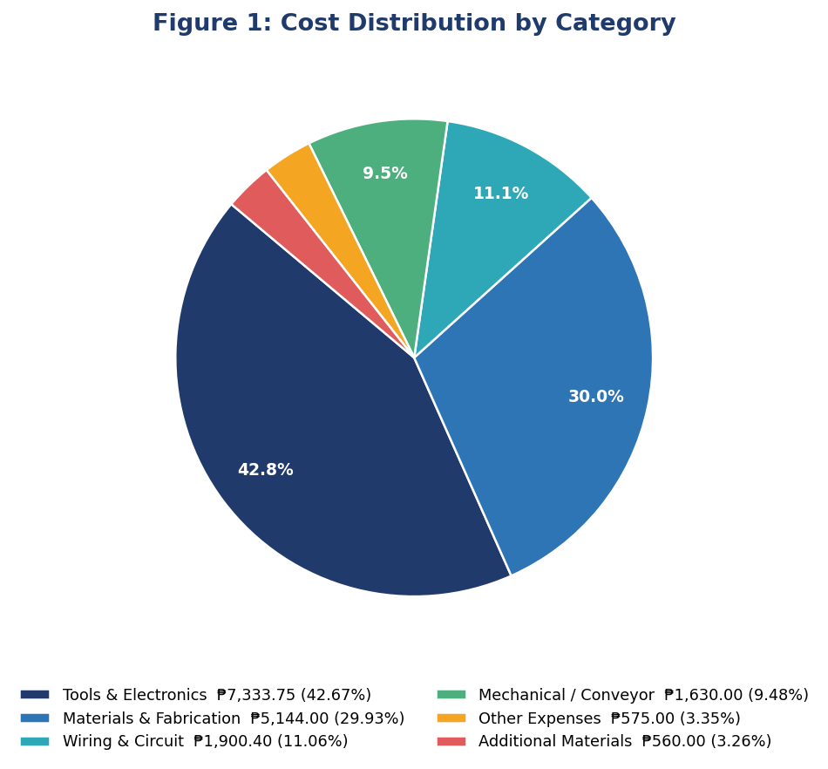
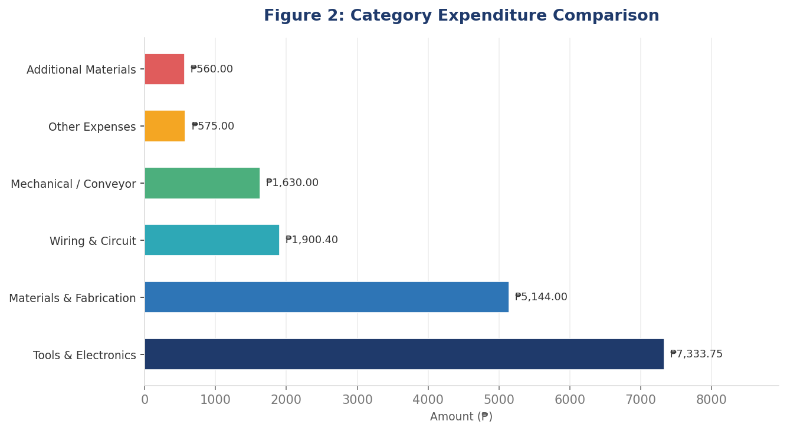
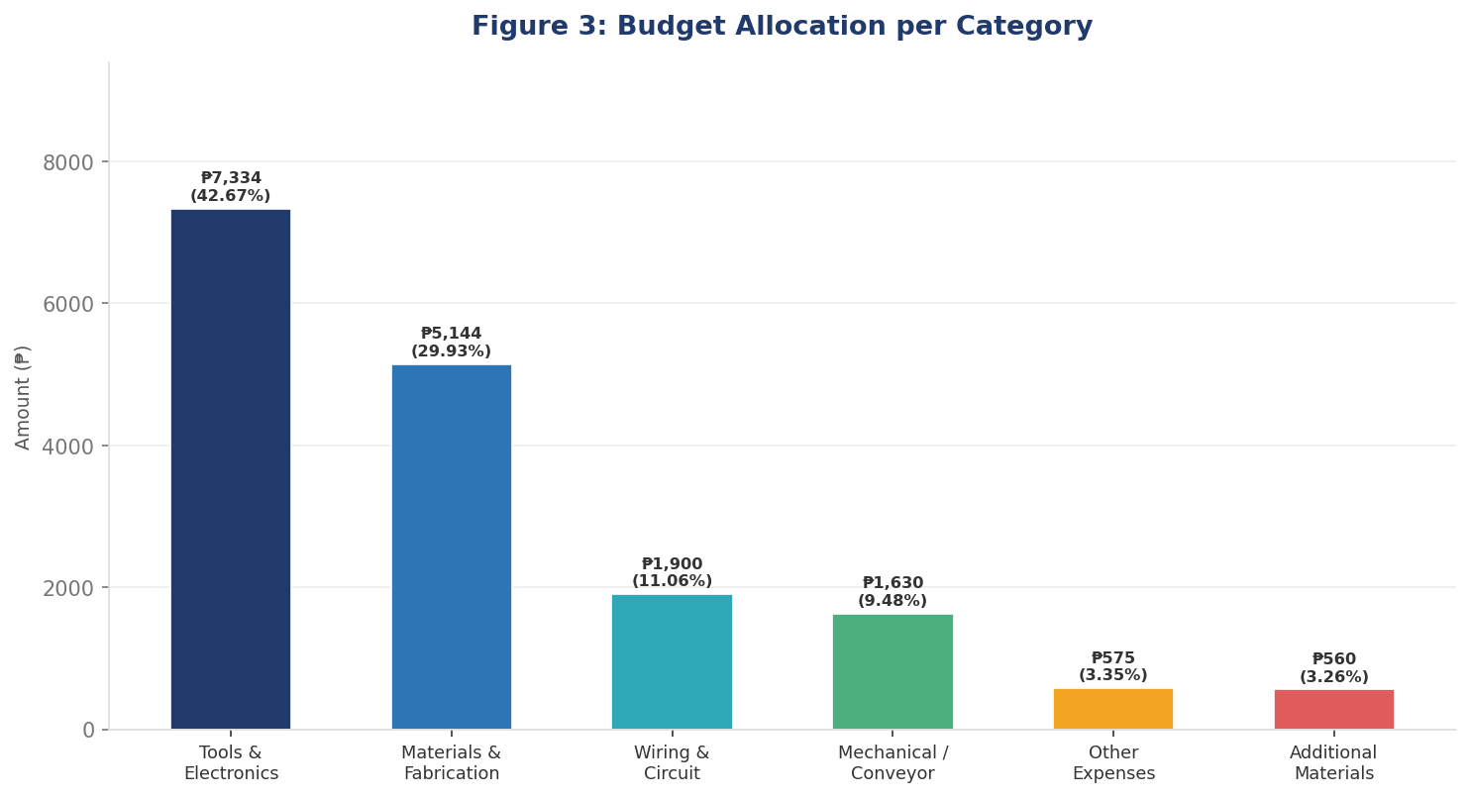
V. MEMBER CONTRIBUTIONS (AMBAG)
# | Member Name | Role | Ambag (₱)
1 | Dado, Kenneth S. | Project Manager
2 | Fajutagana, Kimberly A. | Project Auditor
3 | Balimbingan, Shaina F. | Member
4 | Dacatimban, Kristine Jewel M. | Member
5 | Fernandez, Robyn Kristoffer P. | Member
TOTAL MEMBER CONTRIBUTIONS |  |  | ₱3,642.00

SIGNATORIES
Kimberly A. Fajutagana  Project Auditor | Kenneth S. Dado  Member
Kristine Jewel M. Dacatimban  Member | Shaina F. Balimbingan  Member
Robyn Kristoffer P. Fernandez
Leader

